RAD Project

South Metro TAFE | Burslem Drive

Kyle Cleofe; JASON King; CHRISTINA Tatang

2019

Table of Contents

Introduction 3

Source Control 3

Project Management Plan 3

Analysis Documentation 5

CITE business rules for software development 5

CITE Managed Services Quality Assurance 6

Acme Entertainment Pty Ltd development requirements 6

Multi-platform report (adaptive vs responsive) 8

Responsive Design 8

Adaptive design 8

Test Plan (Sprint One) 11

Introduction 11

Scope 11

Quality Objective 11

Roles and Responsibilities 11

Test Methodology 12

Overview 12

Test Levels 12

Bug Triage 13

Suspension Criteria and Resumption Requirements 13

Test Completeness 13

Test Deliverables 13

Resource & Environment Needs 14

Testing Tools 14

Test Environment 14

Testing Document 15

Scope 15

Testing Case 15

Responsive Layout 16

Home Page 16

Desktop 16

Tablet 17

Mobile 18

Frequent Search Chart 19

Desktop 19

Glossary 20

*ChangeLog*

|  |  |  |  |
| --- | --- | --- | --- |
| **Version** | **Change Date** | **By** | **Description** |
| version number | Date of Change | Name of person who made changes | Description of the changes made |
| V1 | 7/11 | Kyle, Jason | Made master documentation and added analysis.doc |
| V2 | 14/11/2019 | Jason, Kyle, Christina | Edited Analysis documentation, Added Mutli-platform report, Added Test plan, Added Intro, Added Testing Document |
| V2.1 | 20/11 | Kyle | Added and updated testing plan, edited document to be more clear. |
|  |  |  |  |
|  |  |  |  |
|  |  |  |  |
|  |  |  |  |

# Introduction

This document is a collection of other subdocuments that are required for the revision of the ACME movie database application.

## Source Control

We are using GitHub as a source control. Here is a link to our source control <https://github.com/King-Jason/RAD-Team-D>

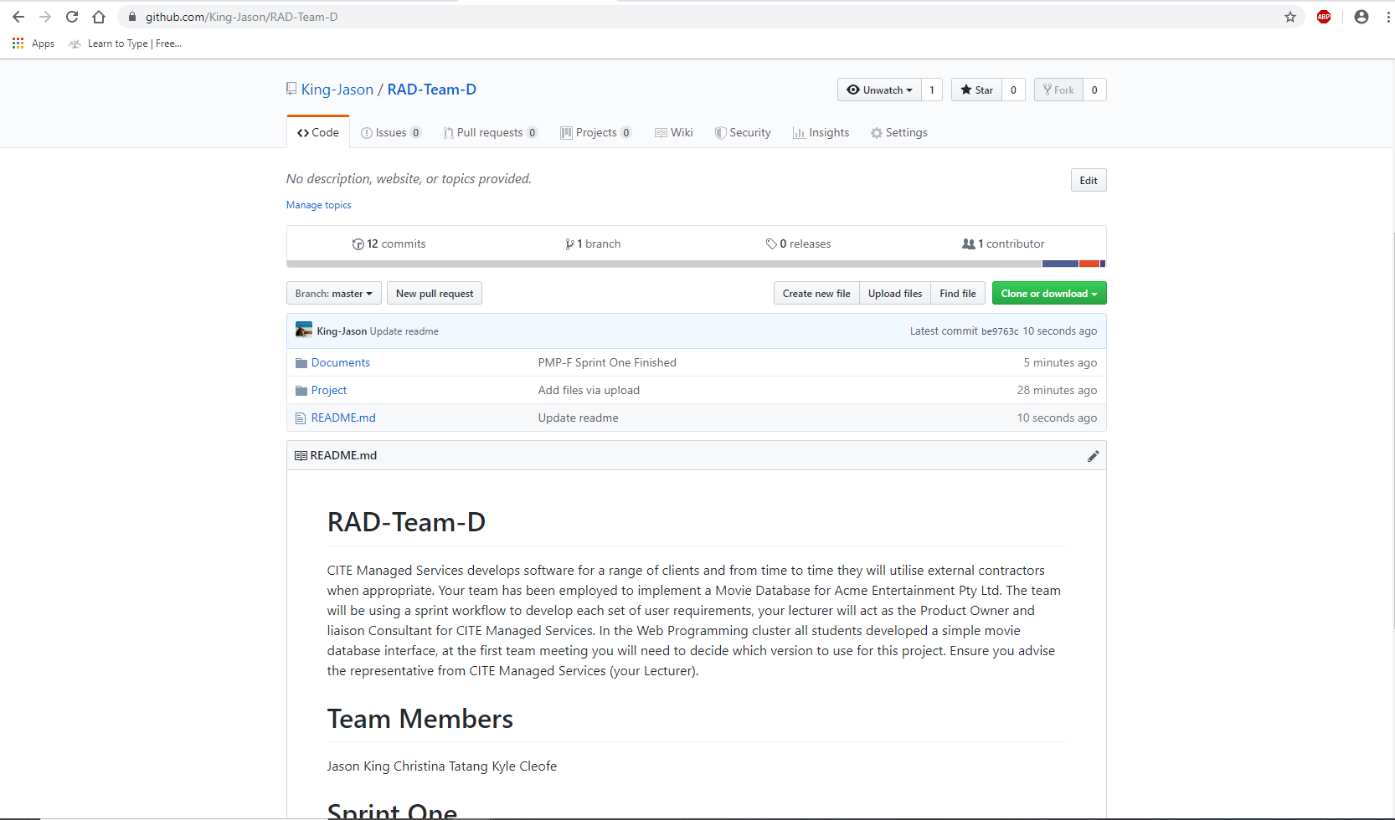

## Project Management Plan

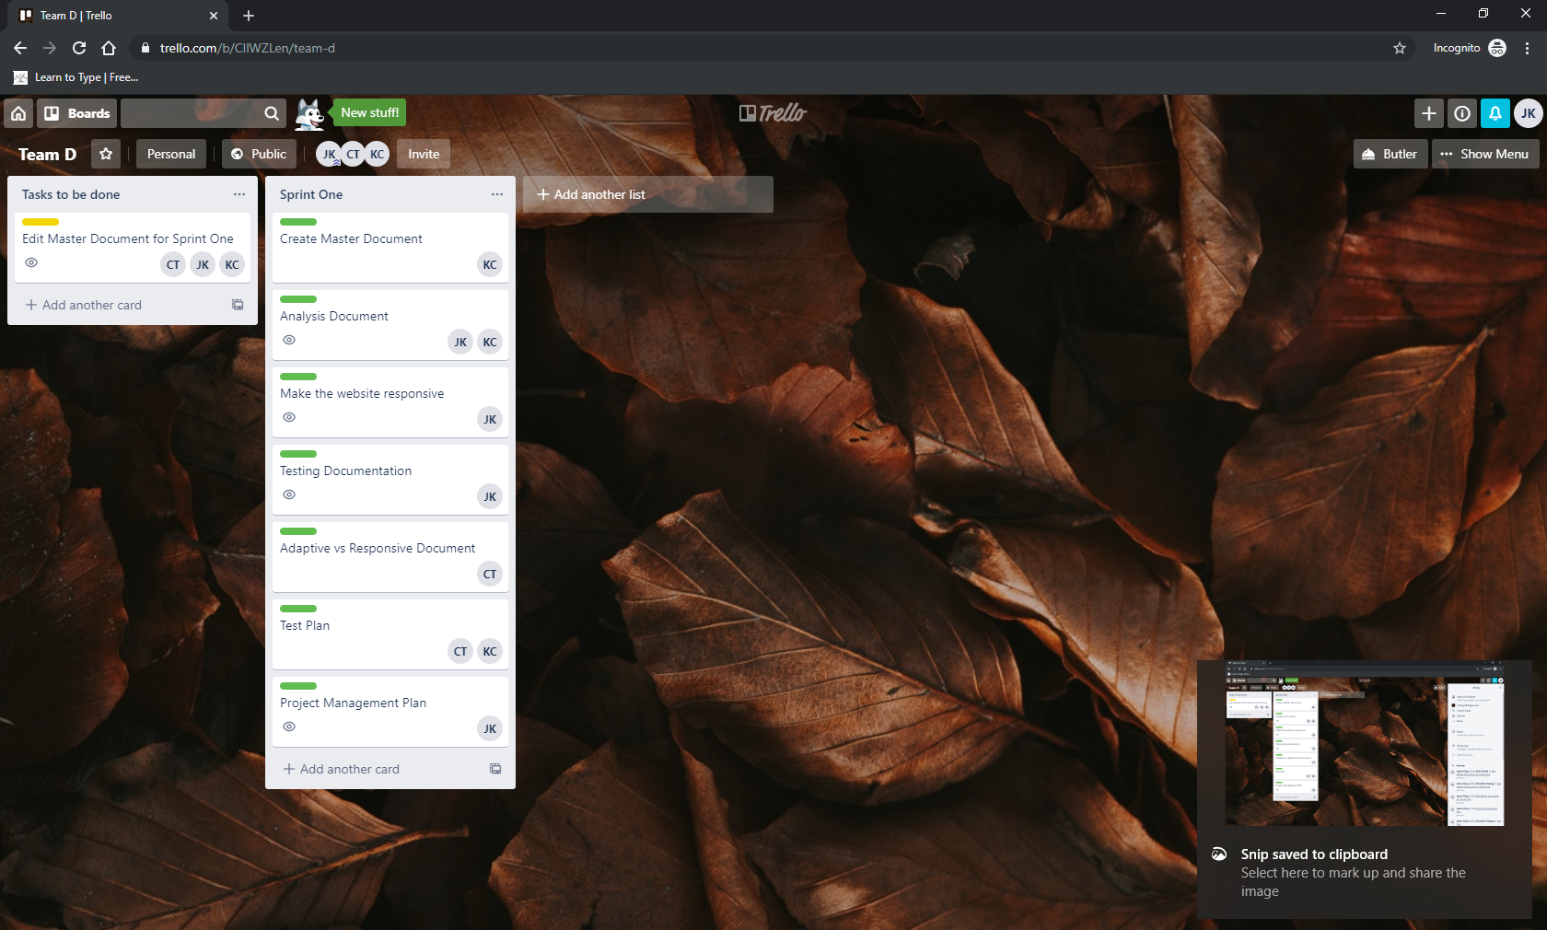

We are using Trello as a project management and collaboration the link is provided below.

<https://trello.com/b/CIlWZLen/team-d>

# Analysis Documentation

## CITE business rules for software development

Our mission is to help enterprises accelerate adoption of new technologies, untangle complex issues that always emerge during digital evolution, and orchestrate ongoing innovation. Whether it is a consumer-oriented app or a trans-formative enterprise class solution, the company leads the process from idealization and concept to delivery, and provides ongoing support through ISO standards and frameworks.

**Clients**

Our clients’ interests always come first. If we deliver exceptional product and service to our clients, our own success will follow.

**Accountability**

We are performance oriented and unafraid to make decisions and be held accountable for those decisions.

**People and reputation**

These are our greatest assets. Without compromise, we will operate in an ethical manner and and in compliance with regulations, wherever we work, and whoever we work with.

**Professionalism and quality**

We take great pride in our work and are driven to achieve excellence in every project we undertake. We aim to deliver the best products and service in the market.

**Innovation, creativity**

We never discount the past, but we will constantly strive to find a better solution to a client’s problems. Our clients’ best interests are our best interests.

**Teamwork**

Individual creativity is always encouraged, but, more often than not, team effort produces the best results. There is no room for those who put their personal interests ahead of the interests of the firm and its clients.

**Size**

We are a small firm. We want to be big enough to undertake the largest project that any of our clients could conceive, yet small enough to maintain the loyalty and camaraderie that contributes to our success.

**Anticipation**

We constantly strive to anticipate changes in markets and technologies and we will deliver the latest services, tools and technology stacks to our clients.

**Growth**

We operate in a highly competitive environment and we will grow our business aggressively. However, we will always be fair competitors and will never denigrate other firms.

**Integrity**

We expect our people to maintain high ethical standards in everything they do.

Ref= <http://www.citems.com.au/?page_id=62>

## CITE Managed Services Quality Assurance

We have established processes that evaluate project performance and aim to assure that quality standards are being followed and that the deliverables comply with customer requirements.

Ref= <http://www.citems.com.au/?page_id=84>

## Acme Entertainment Pty Ltd development requirements

* Review and Update the move database application. Rework the prototype.
* Make a multiplatform report document – adaptive or responsive.
* Move Database local server or cloud hosted.
* Record testing and make a testing document.

CITE Managed Services develops software for a range of clients and from time to time they will utilise external contractors when appropriate. Team D (us) have been employed to implement a Movie Database for Acme Entertainment Pty Ltd.

Sprint One

# Multi-platform report (adaptive vs responsive)

Responsive sites and adaptive sites are the same in that they both change appearance, based on the browser environment they are being viewed on. Both responsive and adaptive design have a very similar objective. They seek to provide the best possible experience on a single website when it’s viewed on a multi-platform (desktop, mobile, tablet devices). In this report, we will explaining the difference between responsive and adaptive design.

## Responsive Design

Responsive Design is the use media queries to serve different CSS allowing a site to change its appearance when viewed on different size screens. So in short it can be accomplished with just plain HTML and CSS. Responsive websites respond to the size of the browser at any given point. No matter what the browser width may be, the site adjusts its layout (any perhaps functionality) in a way that is optimized to the screen.

Responsive design is client-side which means the page is sent to the device browser (the client), and the browser then modifies the appearance of the page in relation to the size of the browser window.

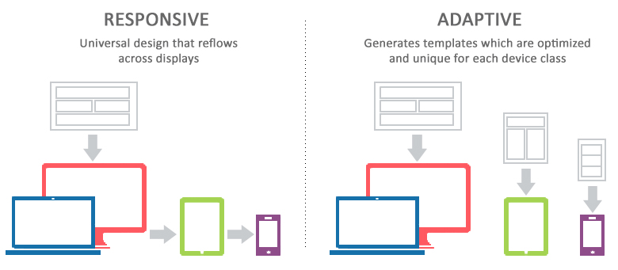

The pros of responsive web design:

1. User experience friendly.
2. Save cost on responsive web design development
3. SEO friendly

The cons of responsive web design:

1. Bad compatibility for the old version of IE browser
2. Slow down the loading
3. Time-consuming on the development
4. Influence on the layout

## Adaptive design

Adaptive design uses predefined layouts that have been carefully constructed for a variety of screen sizes. A particular layout is activated when the screen of the device viewing the website is detected and matched with a style sheet. In other words, the website is only concerned about the browser being a specific width, at which point it adapts the layout.

Adaptive design is predominantly server side. This means that the web server does all of the work of detecting the various devices and loading the correct style sheet depending on the attributes of the device. As well as the layout changing depending on the size of the screen they can also change depending on conditions like whether the device has a retina display or not.

The server can detect this and display high quality images for retina display devices like iPads and lower quality images for standard-definition displays.

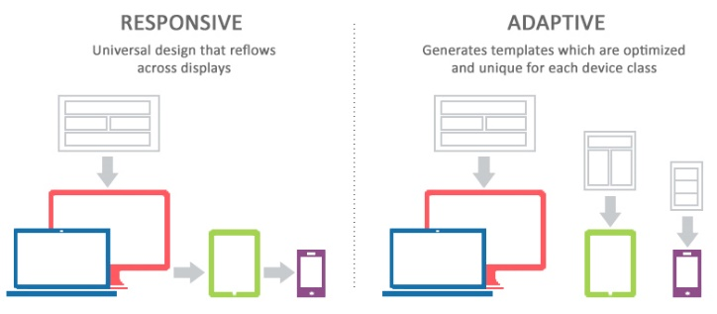

The pros of adaptive design:

1. Faster page loads
2. Optimized user experience
3. Improved SEO
4. Serving a wider audience

The cons of adaptive website design:

1. Labour-intensive
2. Professional required

As the result, our team (team D) will use responsive design for our group project. One of the reasons why we choose responsive design because it is easier and takes less work to implement. It affords less control over the design on each screen size, but it’s by far the preferred method for creating new sites ate this moment. Responsive designers create a single design to be used on all screens and will generally start in the middle of the resolution and use media queries to determine what adjustments will be made for the lower and higher end of the resolution scale. This will tends make users happy, because that familiar web design seems guaranteed to translate across to any device’s screen.

**References**

<https://medium.muz.li/responsive-and-adaptive-design-69604ab1abd4>

<https://css-tricks.com/the-difference-between-responsive-and-adaptive-design/>

<https://www.uxpin.com/studio/blog/responsive-vs-adaptive-design-whats-best-choice-designers/>

<https://www.interaction-design.org/literature/article/adaptive-vs-responsive-design>

<https://www.mockplus.com/blog/post/pros-and-cons-of-responsive-web-design>

<http://mediumwell.com/pros-cons-adaptive-web-design-web-developers-need-know/>

# Test Plan (Sprint One)

## Introduction

This testing plan is the documentation for Assessment Task 2 project for Rapid Application Documentation. In this project, we develop a web site that will show movies information. The website will show movies information including ID, title, studio, status, sound, versions, rec ret price, rating, year, genre, and aspect of the movie. In this website, the user also can search for the name, title, year, and rating and will show the top 10 most searched movies in the bar chart.

This testing plan documentation will explain about the testing that our group will develop in this project. Our strategies will be based on the quality assurance lifecycle at CITE Managed Services including initiation and planning, first review, iteration audits, final verification and validation. The methodology that we will use is rapid application development. The plan identify the items to be tested, the features to be tested, the types of testing to be performed, the personel reponsible for testing, the resources and schedule required to complete testing, and the risks associated with the plan.

### Scope

**In Scope**

The features that we will test are the size of the website and test it on various sizes. The website will be opened on various sizes should be able to responds to or resizes itself depending on the type of device it is being seen through. The website working correctly including the website can be searched using title, rating, year, and genre, the website showing the top 10 most searched movies in bar chart and showing all the movies information correctly.

**Out of Scope**

The features that will not be tested are the website security and performance, high quality website, high performance because they are not included in the software requirements

### Quality Objective

The test objectives are to verify the functionality of the movie database website for our group (team D), the project should focus on testing the responsive functionality that will responds to or resizes itself depending on the type of device it is being seen through and to guarantee all the requirements working correctly as it should be. The other objectives of our testing project should be able to meet all the functional and non-functional requirements, ensure the application under tets meets the quiality specifiations definied by the client, ensure all the bugs or issues are identified and fixed before go live, and ensure all the code meet all the quality assurance standard of CITE.

### Roles and Responsibilities

|  |  |  |
| --- | --- | --- |
| No. | Member | Tasks |
|  | Testers (Christina T, Kyle C, Jason K) | Test the software at different levels and record the results, develop the test specifications, conduct the test and record the results for different items of the software |
|  | Test manager (Jason K) | Prepares test strategy, define test levels and test cycles, coordinate with other teams for software releases, gather the updates on testing progress |
|  | Test designer (Christina T) | The person responsible for creating the test scripts, scenarios, test lives, and so on that make the tests to be performed. |
|  | Test approver (Kyle C) | The person that responsible for reviewing, validating, and approving that test materials created by the test designer. |
|  | Reviewer | The person responsible for reviewing reports from the testers and determining what subsequent actions will be taken. |

## 

## Test Methodology

### Overview

The test methodology for the project we will use is rapid application development. We are using the rapid application development because rapid application development can be used with minimal planning in favor of rapid prototyping. Rapid application development was conceived for this purpose – to develop prototypes rapidly for testing functions and features, without having to worry about how the end product will be affected.

The reasons why we choose rapid application development also because if there are changes of requirements then we can change it any time. This methodologies also focuses on speed, compared to other models which usually focus on bringing a working product to the customer.

### Test Levels

The test levels or test types we will be conducting in our web application under testing are UI testing, grey-box testing, rule based testing and database testing which falls all under RAD methodology testing.

The RAD testing methodology has lots of testing as it requires a test every sprint to ensure that the application is working as expected. We will test the database first if it connects, SQL statements works correctly and running database tests just like we would run our applications.

We would run the grey box testing by testing the web application with a mix of black box testing (testing the UI) and white box testing (testing the source code) to search for defects.

### Bug Triage

Our bug triage will have a process of each bug is prioritized based on its severity and frequrency in our movie application. We will evaluate the bug next and think of a resolution of the defects. We notify our team members on the bugs that occurred on the program and how we fix it. Generally we try to fix the bugs during development of the application.

### Suspension Criteria and Resumption Requirements

Our suspension criteria mainly depend on the working days that we can do the testing procedures such as holidays or weekends. A critical defect is on suspension criterion that cannot allow further testing until the defect is treated and out of the way.

Resumption requirements of the testing procedure may only happen when the holiday period ends or it is a working day, or the fix is successfully implemented and working again making it available for the testing team to continue the testing procedures.

### Test Completeness

The testing criteria will deem the testing complete if the bugs that we found are fixed and all test cases are followed and executed. After testing we work on the code again to fix all the bugs that were found this mainly determines if the test is deemed to be achieved/completed.

## Test Deliverables

The test artifacts that will be delivered during the different testing lifecycles are:

* Test Plan
* Test Documents/Test Cases
* Bug Reports

|  |  |
| --- | --- |
| Test Plan (this document) | the strategy that will be used to verify and ensure that a product or system meets its design specifications and other requirements. |
| Test Document | documentation of artifacts created before or during the testing of software. It helps the testing team to estimate testing effort needed, test coverage, resource tracking, execution progress, etc. It is a complete suite of documents that allows you to describe and document test planning, test design, test execution, test results that are drawn from the testing activity. |
| Bug Report | Reports that contains information needed to reproduce and fix problems. |

## Resource & Environment Needs

### Testing Tools

Testing tools used to test the application:

* XAMPP Control Panel
* PhpMyAdmin
* MySQL
* PHP, CSS, HTML
* Office 365 mainly Microsoft Word
* Notepad++ or Adobe Dreamweaver as a source code editor

### Test Environment

Minimum hardware and software requirements for test environment

1. OS: Microsoft Windows 7
2. Processor: Intel Core i5-4590 CPU @3.30GHz Quad core
3. storage that has a free space of greater than 1MBs
4. RAM: greater than 2GBs
5. Separate GPU is not needed for this game as not much graphics processing is needed and some CPUs already integrate graphics the processor.
6. Hard Drive disk or SSD with a free space of at least 20Mbs.

# Testing Document

## Scope

CITE Managed Services develops software for a range of clients and from time to time they will utilise external contractors when appropriate. Team D (us) have been employed to implement a Movie Database for Acme Entertainment Pty Ltd.

It is required that the website is reworked and updated so it is responsive meaning the layout of the webpages depending on the screen size.

## Testing Case

Testing Case for database searching

|  |  |  |
| --- | --- | --- |
| Case | Description | Screenshot |
| 1 | “Fast” entered into movie detail box returns only movie titles that include “Fast” |  |
| 2 | “Comedy” entered genre detail box returns only comedy movies. |  |
| 3 | “1995” entered into the year detail box returns only movies that were released in “1995”. |  |
| 4 | “NR” was entered into the rating detail box and returned only movies with a rating of NR. |  |

## Responsive Layout

With the responsive layout it won’t necessarily look like the tablet version if the tablet screen is small. If your mobile screen is huge than it will scale around your device screen etc. The database connection will work the same as long as you have an internet connection queries will be sent through.

## Home Page

### Desktop

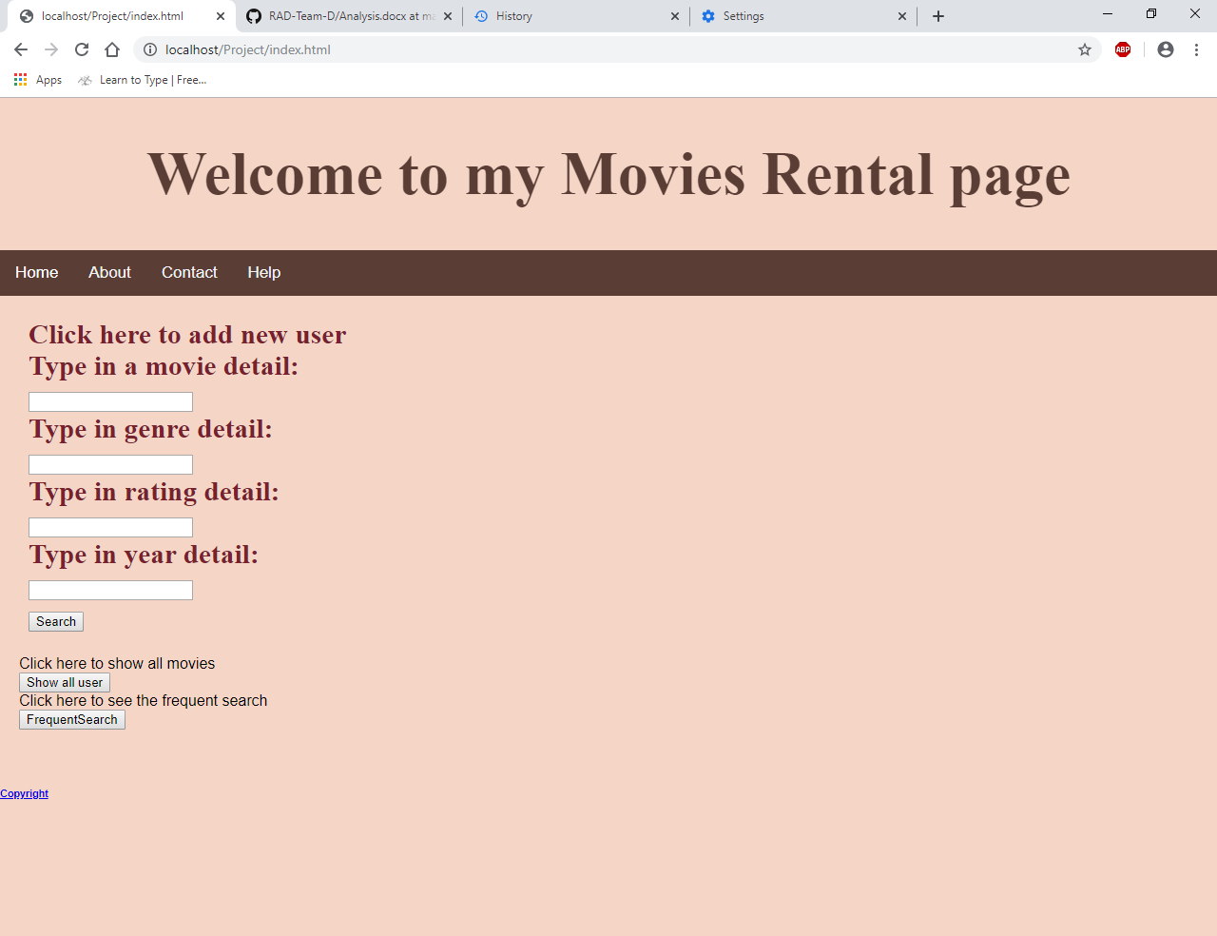

### Tablet

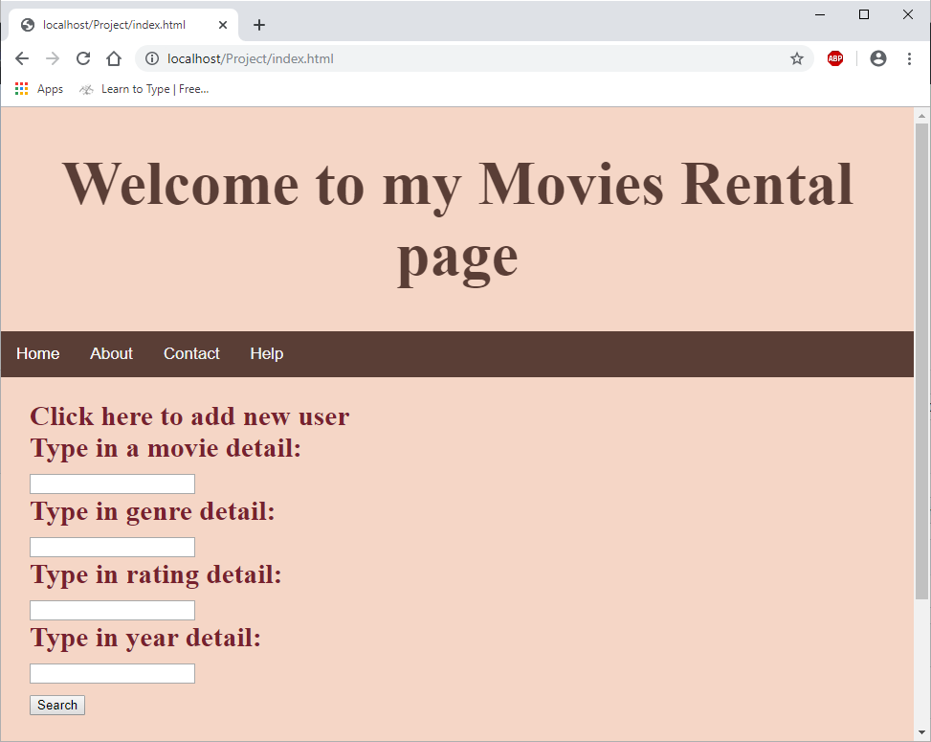

### Mobile

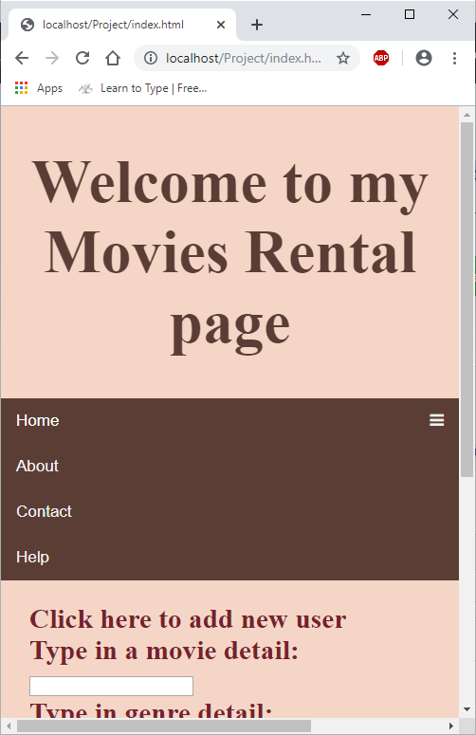

## Frequent Search Chart

### Desktop

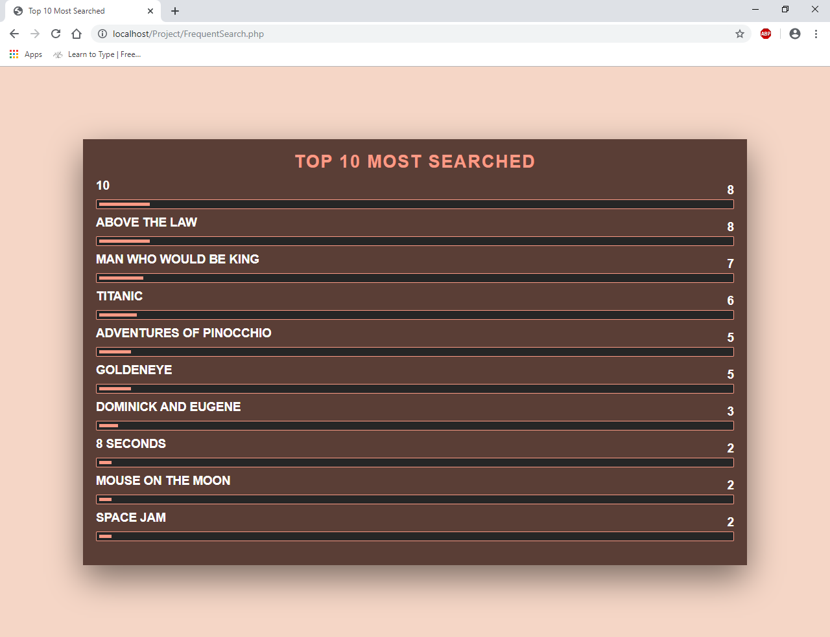

Sprint Two

# Glossary

| TERM/ACRONYM | DEFINITION |
| --- | --- |
| API | Application Program Interface |
| AUT | Application Under Test |
| CSS | Cascading Style Sheets is a style sheet language used for describing the presentation of a document written in a markup language like HTML. |
| HTML | Hypertext Markup Language is the standard markup language for documents designed to be displayed in a web browser. |
| PHP |  |
| SQL |  |
| RAD |  |